E-Enterprise Portal

Be Well Informed

CDX Help Desk Information

9/14/2018

**Be Well Informed** is a tool designed to help domestic well owners understand their well water test results. While many domestic wells provide safe drinking water, certain pollutants like arsenic, iron, and manganese are sometimes present in groundwater at levels that can affect public health and homes. It is important to have domestic wells inspected regularly, and the Be Well Informed tool now makes inspection results easier to understand. The tool allows users to input information from a well inspector company’s test results, and then translates that information back to the user in plain language. Additionally, if a problem is detected in the well water, Be Well Informed provides solution suggestions recommended by the well owner’s state, tribe or territory.

**Locations**: New Hampshire, Wyoming and Massachusetts are in production. Minnesota, Michigan, Vermont, and Virginia are currently onboarding. The decision whether to adopt the widget rests with states, tribes or territories.

**Function**: calculator

**User’s guide or FAQS**: Onboarding kit for potential partners (States/Tribes/Territories), but this material is not typically for end users.  There is a NHDES Be Well Informed Guide for New Hampshire well owners at: [https://www4.des.state.nh.us/DWITool//Welcome.aspx](https://www4.des.state.nh.us/DWITool/Welcome.aspx). Other states do not have similar, nor will this guide be suitable for other states.

**Potential users**: As of now, New Hampshire expects about ~300 calls per year before implementing this widget.  No idea nationally or state by state including MA. States and EPA are planning communications with other potential partners.

**Tracking**: Track inquiries as Be Well Informed under E-Enterprise Portal.

**Questions from the HelpDESK**

**Can I choose which contaminants I would like users to see or not see (add or remove)?**  Yes, the contaminant lists are configurable allowing States, Tribes and Territories to provide information for the most appropriate contaminants in their geography.  Partners may also choose to start with a limited number of contaminants and add additional elements over time.

* We see where the partner can choose which contaminant is within their lists (Page 5 under Customization).  If users cannot locate a contaminate, would that be an area where the Helpdesk would be the proper contact?  The Helpdesk would then report that to a particular entity?

1. **Is there a particular entity who is supporting the partners initial xml setup?**  Will the Helpdesk be the correct entity for the partner to contact where the Helpdesk would then have a particular entity to contact for support
2. **It appears the CDX Contractor (Helpdesk Tier 1 and 2) will be supporting the Calculator function.**  Can we obtain the level of expected support?

* Will the Helpdesk be guiding the user through the data entry from their sampling and need to understand the selections for the chemicals (second screen capture below depicting the calulator).  Please confirm that any calculator issues would be a standard escalation to CGI Federal (Tier 3).

1. **Is the calculation function usable in all browsers or are there known limitations in a particular browser?**
2. Here is some content for the first line in the table below list:

|  |  |  |  |
| --- | --- | --- | --- |
| Roles | Questions/Issue | Route to | Action |
| Public Use | Function | CDX Help Desk | Assist users with Tier 1 and 2 issues and escalate Tier 3 issues to CDX Developer (CGI Federal) |

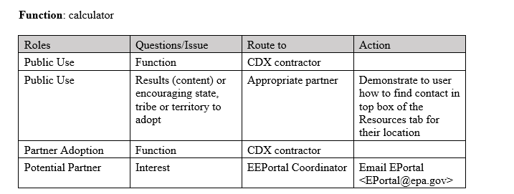

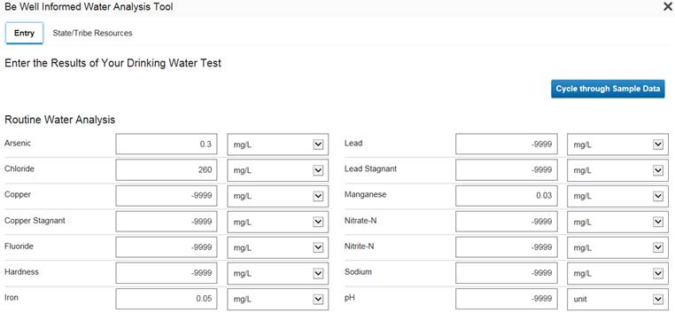

Thanks